Using a neural network model to forecast flood events on the Big Thompson River

W. S. Huffman¹, A. K. Mazouz²

¹Nova Southeastern University, Davies, Florida, USA

²Florida Atlantic University,

Abstract
For the entire period of recorded time, floods have been a major cause of loss of life and property. Methods of prediction and mitigation range from human observers to sophisticated surveys and statistical analysis of climatic data. In the last few years, researchers have applied computer programs called Neural Networks or Artificial Neural Networks to a variety of uses ranging from medical to financial. The purpose of the study was to demonstrate that Neural Networks can be successfully applied to flood forecasting.
The river system chosen for the research was the Big Thompson River, located in North-central Colorado, United States of America. The Big Thompson River is a snow melt controlled river that runs through a steep, narrow canyon. In 1976, the canyon was the site of a devastating flood that killed 145 people and resulted in millions of dollars of damage.
Using publicly available climatic and stream flow data and a Ward Systems Neural Network, the study resulted in prediction accuracy of greater than 97% in +/-100 cubic feet per minute range. The average error of the predictions was less than 16 cubic feet per minute.
To further validate the model’s predictive capability, a multiple regression analysis was done on the same data. The Neural Network’s predictions exceeded those of the multiple regression analysis by significant margins in all measurement criteria.

Keywords: Flood forecasting, neural networks, hydrologic modelling ,rainfall/ runoff,

Introduction
One of the major problems in flood disaster response is that floodplain data are out of date almost as soon as the surveyors have put away their transits.
What is needed in flood forecasting is a system that can be continuously updated without the costly and laborious resurveying that is the norm in floodplain delineation
Even current models that rely on linear regression require extensive data cleaning, which is time and data intensive. A new model must be created every time there is a change in the river basin. The process is time, labor, and, data intensive; and, as a result, it is extremely costly. What is needed is a method or model that will do all of the calculations quickly, accurately, using data that requires minimal cleaning, and at a minimal cost. The new model should also be self-updating to take into account all of the changes occurring in the river basin.
With a NN program, a watershed and its associated floodplains can be updated constantly using historical data and real-time data collection from existing and future rain gauges, flow meters, and depth gauges. The constant updating will result in floodplain maps that are current and accurate at all times.
Another problem with published floodplains is that they depict only the 100-year flood. This flood has a 1% probability of happening in any given year. While this is useful for general purposes, it may not be satisfactory for a business or a community that is planning to build a medical facility for non-ambulatory patients. For a facility of this nature, a flood probability of .1% may not be acceptable. The opposite situation is true for the planning of a green belt, golf course, or athletic fields. In this situation, a flood probability of 10% may be perfectly acceptable.
This paper is an effort to demonstrate the potential use, by a layperson, of a commercially available NN to predict stream flow and probability of flooding in a specific area. In addition, a comparison was made between a NN model and a multiple-linear regression model

Literature
Throughout the literature the terms NN and ANN (Artificial Neural Network) are used interchangeably. They both refer to an artificial (manmade) computer program. The term NN is used in this dissertation to represent both the NN and ANN programs.
The concept of s dates back to the third and fourth Century B.C. with Plato and Aristotle, who formulated theoretical explanations of the brain and thinking processes. Descartes added to the understanding of mental processes. W. S. McCulloch and W. A. Pitts (1943) were the first modern theorists to publish the fundamentals of neural computing. This research initiated considerable interest and work on NNs
Muller & Reinhardt, (1990) wrote one of the earliest books on NNs. The document provided basic explanations and focus on NN modeling (Muller & Reinhardt, 1990). Hertz, Krogh, and Palmer (1991) presented an analysis of the theoretical aspects of NNs (Hertz, Krogh, & Palmer, 1991).
In recent years, a great deal of work has been done in applying NNs to water resources research.
Hjelmfelt et al (1993) used NNs to unit hydrograph estimation. The authors concluded that there was a basis, in hydrologic fundamentals, for the use of NNs to predict the rainfall-runoff relationship. (Hjelmfelt & Wang, 1993).
While NNS are being applied to a wide range of uses, no records of NN applications in the direct management of floodplains, floodplain maps, or other disaster response programs were found. The closest application is a study done to model rainfall-runoff processes (Hsu et al., 1995).
Huffman (2001) presented a paper that suggested that NNs could be applied to creating floodplains that could be constantly updated without relying on the costly and time consuming existing modeling techniques (Huffman, 2001).
Wei et al (2002) proposed using NNs to solve the poorly structured problems of flood predictions.
Rajurkar, Kothyari, and Chaube (2004) tested a NN on seven river basins. They found that this approach produced reasonably satisfactory results from a variety of river basins from different geographical locations..
Kerh and Lee (inpress) describe their attempt at forecasting flood discharge at an unmeasured station using upstream information as an input. They discovered that the NN was superior to the Muskingum method (Kerh & Lee, 2006).
Filo and dos Santos (2006) applied NNs to modeling stream flow in a densely urbanized watershed.
Sahoo and Ray (2006) described their application of a feed-forward back propagation and radial basis NN to forecast stream flow on a Hawaii stream prone to flash flooding.
Late in this study, a paper by (Hsu et al., 1996), was discovered demonstrating that results were dramatically improved by adding the previous day’s stream flow or stage level input with the other data. This technique was applied in this study. This application resulted in a dramatic improvement of the predictive capability of the model (Hsu et al., 1996).

Methodoligy
Current methods of stream-flow forecasting are based on in-depth studies of the river basin including (a) geologic studies, (b) topographic studies, (c) ground cover, (d) forestation, and (e) hydrologic analysis. All of these are time and capital intensive. Once these studies have been completed, hydrologists attempt to create algorithms to explain and predict river flow patterns and volumes. The least advantageous part of this is that they represent the river basin at one point in time. River basins are dynamic entities that change over time. The dynamic nature of river basins causes the studies to become less and less accurate as the characteristics of the river basins change through natural and human-made changes.
Several independent variables were considered, and two test bed data sets are used, the Drake and Loveland data sets.
The Drake measuring station is described as, “USGS 06738000 Big Thompson R at mouth OF canyon, NR Drake, CO.” (USGS, 2006b). Its location is: Latitude 40°25'18", Longitude 105°13'34" NAD27, Larimer County, Colorado, Hydrologic Unit 10190006. The Drake measuring station has a drainage area of 305 square miles and the Datum of gauge is 5,305.47 feet above sea level.
The Loveland measuring station is described as USGS06741510 Big Thompson River at Loveland, CO.(USGS, 2006b). Its location is Latitude 40°22'43", Longitude 105°03'38" NAD27, Larimer County, Colorado, Hydrologic Unit 10190006. Its drainage area is 535 square miles and is located 4,906.00 feet above sea level
The records for both sites are maintained by the USGS Colorado Water Science Center p (USGS, 2006a and b).
The following data was used in this model:
Tmax is the maximum measured temperature at the gauging site.
Tmin is the lowest measured temperature at the gauging site.
Tobs is the current temperature at the gauging site.
Tmean is the average temperature during the 24-hour measuring period
Cdd are the Cooling Degree Days, an index of relative coldness.
Hdd are the Heating Degree Days, an index of relative warmth.
Prcp is the measured rainfall during the 24-hour measuring period.
Snow1 is the measured snowfall during the 24-hour measuring period.
Snwd is the measured depth of the snow at the measuring site.
The output variable is the predicted flow level.
This is the actual data collected by the meteorological stations. The samples for each site are more than 3000 data sets which are more than enough to (a) run a NN model, (b) to test it, and (c) to validate it. For the same data, a linear regression model using SPSS was run. The same variables dependent and independent were considered (Mazouz, 2006).
The Ward Systems product, selected for the research, is the NeuralShell Predictor, Rel. 2.0, Copyright 2000. The following description was taken directly from the Ward Systems website, www.wardsystems.com (Ward Systems Group, 2000).
The methods of statistical validation to be used in this paper are as follows:
R-Squared is the first performance statistic known as the coefficient of multiple determination, usually applied to multiple regression analysis.
Average Error is the absolute value of the actual values minus the predicted values divided by the number of patterns.
Correlation
$r=N⋅\left[\sum_{i=1}^{N}{(x_{i}⋅y_{i})}\right]−{\left[\sum_{i=1}^{N}{x_{i}}\right]⋅\left[\sum_{i=1}^{N}{y_{i}}\right]}/{\sqrt{N⋅\left[\sum_{i=1}^{N}{x_{i^{2}}}\right]−{\left[\sum_{i−1}^{N}{x_{i}}\right]}^{2}}}⋅\sqrt{N⋅\left[\sum_{i=1}^{N}{y_{i^{2}}}\right]−{\left[\sum_{i=1}^{N}{y_{i}}\right]}^{2}}$

This is a measure of how the actual and predicted correlate to each other
in terms of direction (i.e., when the actual value increases, does the predicted value increase and vice versa). The closer the correlation value is to one, the more correlated the actual and predicted values (Ward Systems Group, 2000).
Mean Squared Error is a statistical measure of the differences between the values of the outputs in the training set and the output values the network is predicting. (Ward Systems Group, 2000).
Root Mean Squared Error (RMSE) is the square root of the MSE.
Percent in Range is the percent of network answers that are within the user-specified percentage of the actual answers used to train the network (Ward Systems Group, 2000).

4 Analysis and Presentation of Findings

The Ward Systems Neural Shell Predictor was applied to model rainfall/snowmelt-runoff relationship using observed data from the Big Thompson watershed located in North-central Colorado.
The Ward Systems Neural Shell Predictor is an extremely versatile program offering a number of choices of data processing and error criteria. These choices are also discussed.
The following is a topographic map of the Big Thompson canyon. It is a narrow, relatively steep canyon.

Figure 5. Topography of the Big Thompson Canyon (USGS & Inc, 2006).
The historical measurements of (a) precipitation, (b) snowmelt, (c) temperature, and (d) stream discharge are available for the Big Thompson Watershed as they are usually available for most watersheds throughout the world. This is in contrast to data on (a) soil characteristics, (b) initial soil moisture, (c) land use, (d) infiltration, and (e) groundwater characteristics that are usually scarce and limited.
For this study, six climatic observation stations were used for the input variables. For the purposes of building a model to demonstrate the feasibility of using the commercially available NN, all six stations’ data were used for the independent variables. The description and locations of the stations are as follows.

Coopid. Station Name Ctry. State County Climate Div. Lat./Long. Elevation
051060 Buckhorn Mtn 1E U.S. CO Larimer 04 40:37/ -105:18 2255.5
052759 Estes Park U.S. CO Larimer 04 40:23/-105:29 2279.9
052761 Estes Park 1 SSE U.S. CO Larimer 04 40:22/-105:31 2372.9
054135 Hourglass Res. U.S. CO Larimer 04 40:35/-105:38 2901.7
055236 Loveland 2N U.S. CO Larimer 04 40:24 /-105:07 1536.2
058839 Waterdale U.S. CO Larimer 04 40:26/ -105:13 1594.1
(NCDC, 2006)

The period of time for the historical data selected was from July 4, 1990, through May 7, 1998, a total of seven years, ten months and three days.
The Actual versus Predicted results for both the Drake and the Loveland measuring stations are greatly improved in this final model. One extreme event occurred during this time period that was well out of the range of data available and was not adequately predicted by this NN. It is well known that a NN cannot predict an event that it has never seen before in the training data. There was no repeat of the magnitude of this event during the time period under study.
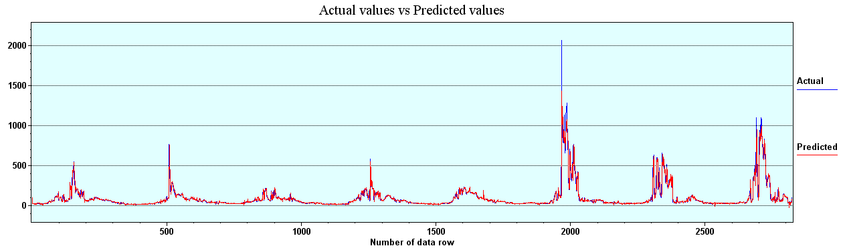
Figure 26. Drake Final Model, Actual versus Predicted.
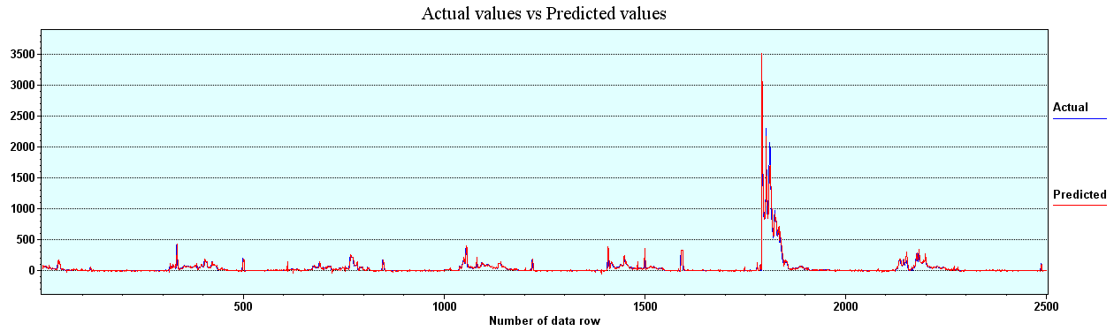
Figure 27. Loveland, Final Model, Actual versus Predicted.
R-Squared for this run improved greatly over the first two models for both measuring stations.
The Drake measuring station results for R-Squared started at just under .90 and improved slightly over the addition of 80 hidden neurons to a value of .9091.
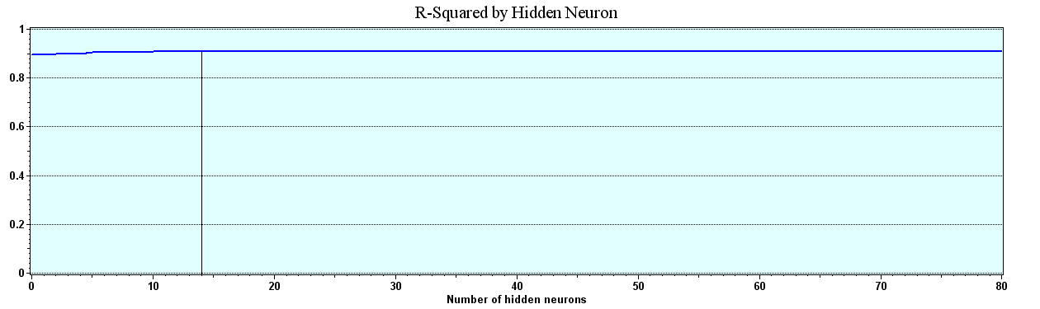
Figure 28. Drake, Final Model, R-Squared.
The R-Squared results for Loveland started at about .86 and improved over the run of data to a value of .9671.
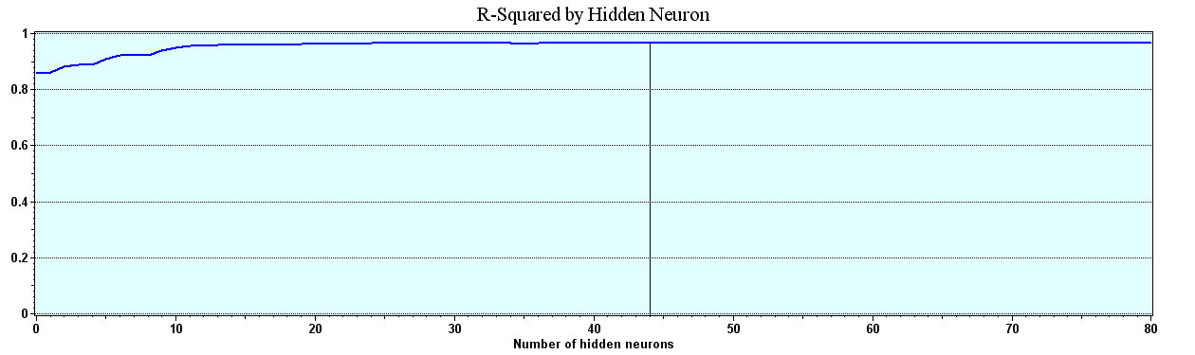
Figure 29. Loveland, Final Model, R-Squared.
The Average Error for the final model improved dramatically.. Both the Drake measuring station and the Loveland measuring station showed very tight average errors.
The Average Error for the Drake Measuring station started the run at about 15.7 cubic feet per minute and decreased over the run to a final value of 15.24 cubic feet per minute.
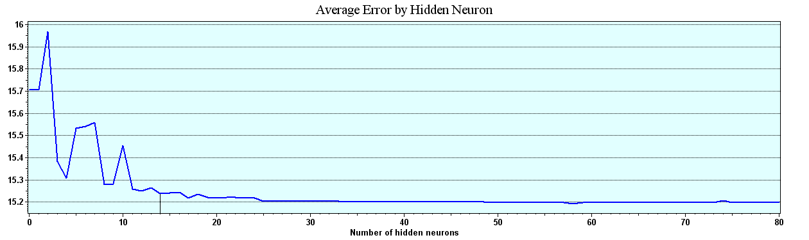
Figure 30. Drake, Final Model, Average Error.
The Average Error for the Loveland measuring station started the run at about 26 cubic feet per minute and decreased to a value of 11.56 Cubic feet per minute.
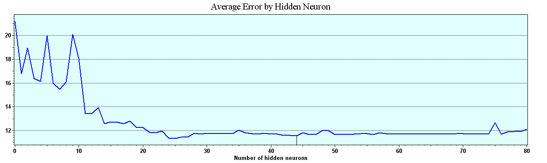
Figure 31. Loveland, Final Model, Average Error.
The Correlation values for both the Drake measuring station and the Loveland measuring station for this model are very good.
The Correlation for this model at the Drake measuring station is .9534.
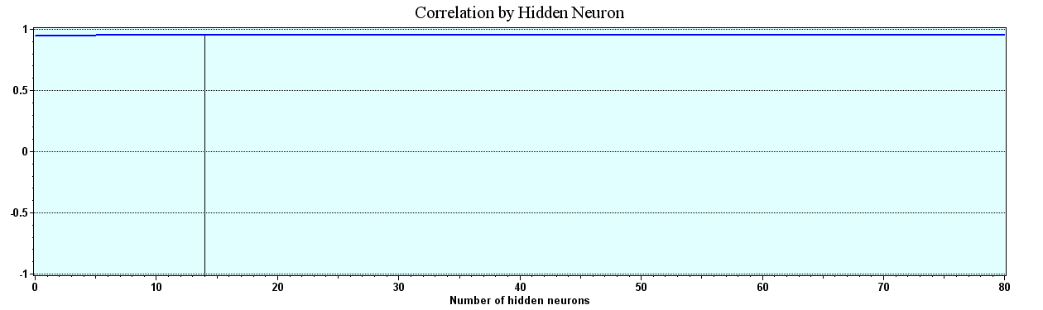
Figure 32. Drake, Final Model, Correlation.
The Correlation at the Loveland measuring station is 98.34.
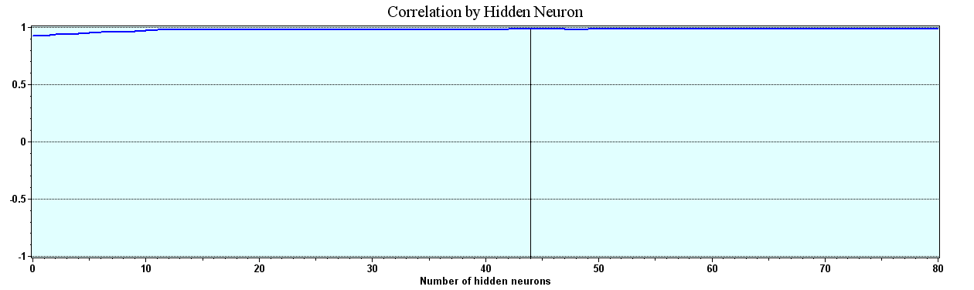
Figure 33. Loveland, Final Model, Correlation.
For this final model, both Mean Squared Error and RMSE are calculated and presented below.
The Mean Squared Error as measured for the Drake measuring station started at a value of 2280 and declined over the addition of 80 hidden neurons to a value of 1993.011.
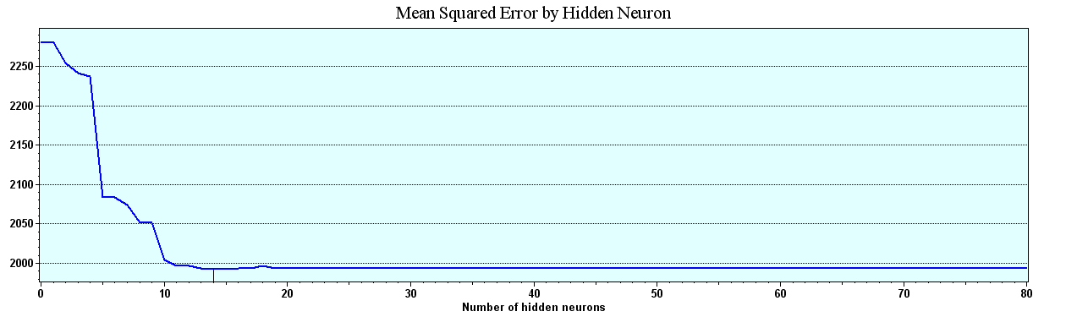
Figure 34 Drake. Final Model Mean Squared Error.
The Mean Squared Error for the Loveland measuring station started at a value of about 4400 and declined to a value of 1016.943.
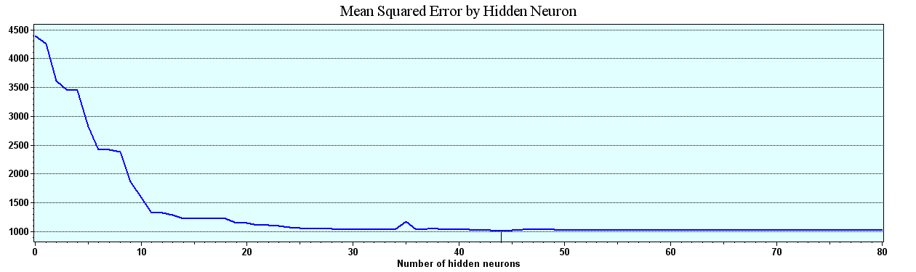
Figure 35. Loveland, Final Model, Mean Squared Error.
The following charts are the results of the RMSE calculations for both Drake and Loveland measuring stations for this final model.
For the Drake measuring station, the RMSE started at 47.75 and declined to a low of 44.64 by the addition of the 80th hidden neuron.
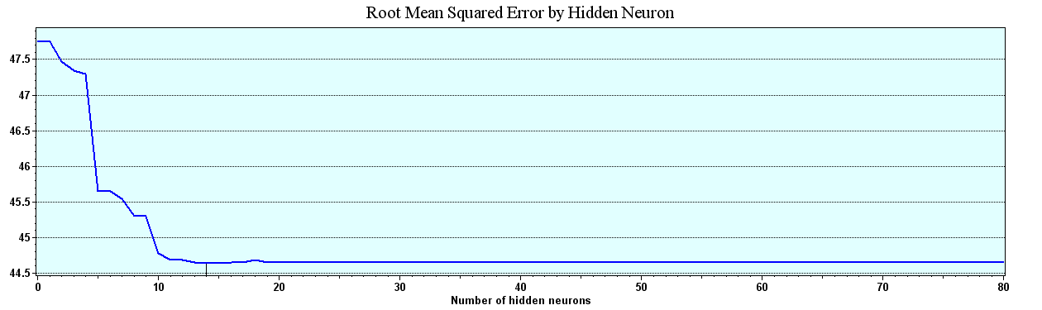
Figure 36. Drake, Final Model, RMSE.
The RMSE at the Loveland measuring station started the run at about 66 and declined to a value of 31.89
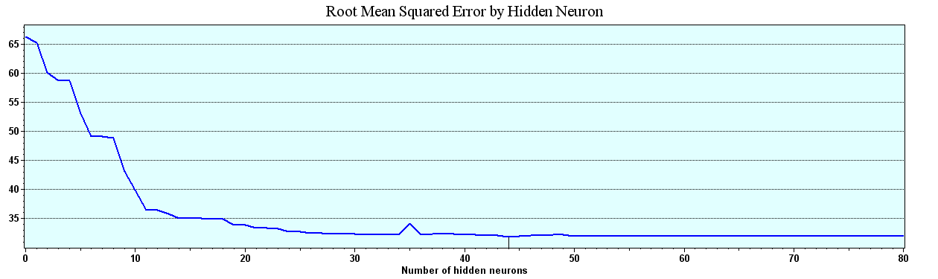
Figure 37. Loveland, Final Model, RMSE.
The Percent in Range for this final model improved exceptionally over the previous models. For the Drake measuring station, the Percent in Range with this final model started and ended at 97.3 percent. Being in excess of 95 percent, this model meets the author’s criteria of greater than 95 percent in range accuracy.
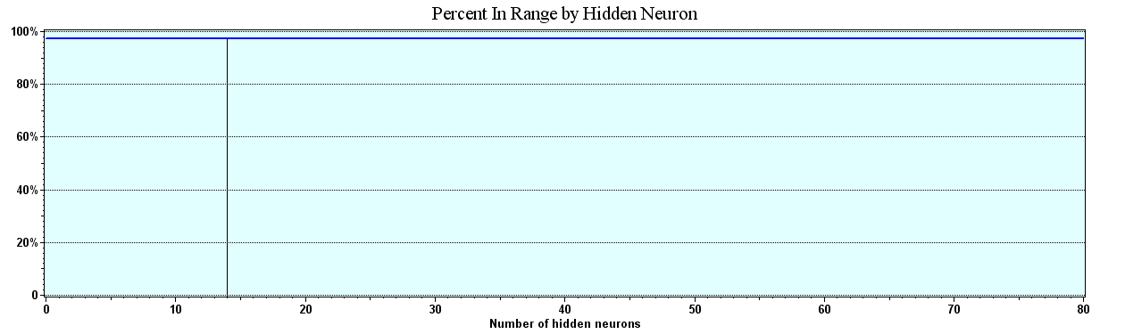
Figure 38. Drake, Final Model, Percent in Range.
The Loveland measuring station’s Percent in Range ended the run at a value of 98.1. Again, this is well above the 95 percent in range criteria set by this author.
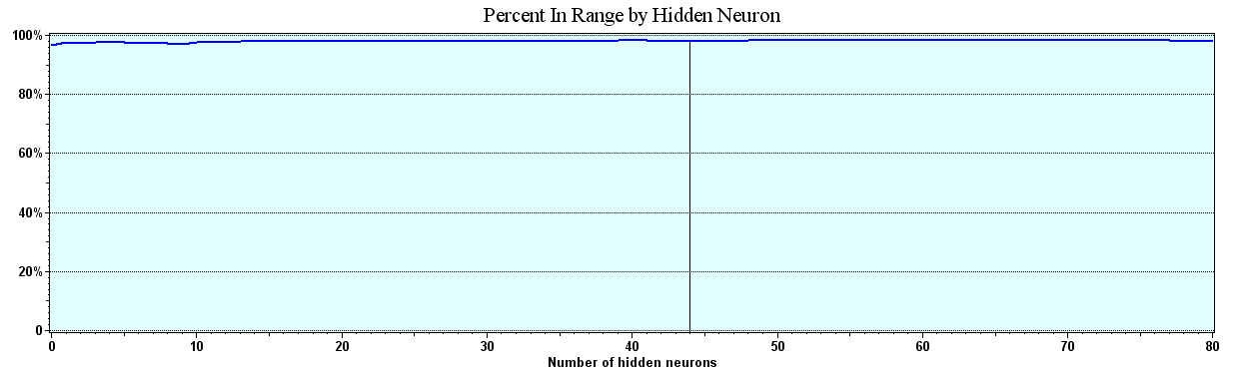
Figure 39. Loveland, Final Model, Percent in Range.

The following Multi linear regression models were created and provided by Dr. Kadar Mazouz of Florida Atlantic University (Mazouz, 2006).
A stepwise multi-linear regression model was generated for both data sets, Drake and Loveland. Being a multiphase process, it stopped after the seventh model. It gave an R-square of .0849, which is less than the NN Model generated for the Drake Data sets.
Actually, the independent variables that contributed the most to the variability of the output are Preflow, TOBS3, Prcp2, Prcp4, Prcp5, and Snow5. Their corresponding coefficients in the model are:

Drake, Model Summary (i)
Model | R | R Square | Adjusted R Square | Std. Error of the Estimate
1 | .916(a) | .838 | .838 | 29.0311
2 | .918(b) | .842 | .842 | 28.7095
3 | .918(c) | .843 | .843 | 28.6109
4 | .919(d) | .845 | .845 | 28.4290
5 | .920(e) | .846 | .845 | 28.3747
6 | .920(f) | .847 | .846 | 28.3096
7 | .921(g) | .849 | .848 | 28.1527
(a) Predictors: (Constant), Preflow
(b) Predictors: (Constant), Preflow, Tobs3
(c) Predictors: (Constant), Preflow, Tobs3, Prcp2
(d) Predictors: (Constant), Preflow, Tobs3, Prcp2, Prcp4
(e) Predictors: (Constant), Preflow, Tobs3, Prcp2, Prcp4, Tmax3
(f) Predictors: (Constant), Preflow, Tobs3, Prcp2, Prcp4, Tmax3, Prcp5
(g) Predictors: (Constant), Preflow, Tobs3, Prcp2, Prcp4, Tmax3, Prcp5, Snow5
(h) Dependent Variable: OUTPUT
On the other hand, as for the Loveland, the stepwise Multi-linear regression model was generated in eight iterations. It gave an R-square of 0.80, which is less than the R-square generated for the Loveland data using NNs.
Actually, the independent variables that contributed the most to the variability of the output are Preflow, OFestes, Prcp3, PrcpA, Tmin3, Snow A, Tobs A. Their corresponding coefficients in the model are:
Table 6

Loveland, Summary (i)
Model | R | R Square | Adjusted R Square | Std. Error of the Estimate
1 | .881(a) | .777 | .776 | 22.06113
2 | .891(b) | .793 | .793 | 21.23824
3 | .892(c) | .796 | .796 | 21.09537
4 | .893(d) | .798 | .797 | 21.01388
5 | .894(e) | .799 | .798 | 20.95246
6 | .895(f) | .801 | .800 | 20.85033
7 | .896(g) | .803 | .801 | 20.80284
8 | .896(h) | .803 | .802 | 20.76851
(a) Predictors: (Constant), Preflow
(b) Predictors: (Constant), Preflow, OFEstes
(c) Predictors: (Constant), Preflow, OFEstes, Prcp3
(d) Predictors: (Constant), Preflow, OFEstes, Prcp3, Prcp_A
(e) Predictors: (Constant), Preflow, OFEstes, Prcp3, Prcp_A, Tmin3
(f) Predictors: (Constant), Preflow, OFEstes, Prcp3, Prcp_A, Tmin3, Tmax1
(g) Predictors: (Constant), Preflow, OFEstes, Prcp3, Prcp_A, Tmin3, Tmax1, Snow_A
(h) Predictors: (Constant), Preflow, OFEstes, Prcp3, Prcp_A, Tmin3, Tmax1, Snow_A, Tobs_A
(i) Dependent Variable: LvdFlow

Summary and Conclusions
In this dissertation, a daily rainfall-runoff model for two flow-measuring stations, Drake and Loveland, on the Big Thompson River in Colorado, was developed using a Ward System NN program called the NeuralShell Predictor. The study attempts to demonstrate the feasibility of using a commercially available NN to accurately predict day-to-day normal flows of a river and to predict extreme flow conditions commonly called flood events. In developing this model, the following topics were addressed: (a) the use of a commercially available NN in the development of the daily rainfall, snowmelt, temperature-runoff process; (b) the evaluation of the reliability of future predictions for this NN program; and (c) the comparison of results of the to a Linear Multiple Regression model developed by Dr. Mazouz (Mazouz, 2006).
Since the early years of the twentieth century, models have been developed to forecast stream-flow. Continuous-process models that are currently available have very complex model formulations. These models are very difficult to apply because of the large number of model parameters and equations that define the components of the hydrologic cycle. The calibration of model parameters is usually accomplished by a trial and error process. As a result, the calibration accuracy of the models is very subjective and highly dependent on the user’s ability, knowledge, and understanding of the components of the model and the watershed characteristics.
The literature shows that NN methodology has been reported to provide reasonably good solutions for circumstances where there are complex systems that are (a) poorly defined and understood using mathematical equations, (b) problems that deal with noisy data or involve pattern recognition, and (c) situations where input data is incomplete and ambiguous by nature. It is because of these characteristics, that it is believed an NN could be applied to model the daily rainfall-runoff relationship. It was demonstrated that the NN rainfall-runoff models exhibit the ability to extract patterns in the training data. The testing accuracy that is compared favorably to the training accuracy, based on the ratio of standard error to standard deviation and percent prediction of peak flows, supports this belief. For the Big Thompson River, the NN provides better than 97 percent predictions within a plus or minus 100 cfm range. This is as accurate as or better than most flood prediction accuracy of any other models of which this author is aware. Based on goodness-of-fit statistics, the accuracy of this NN model compares favorably to the model accuracy of existing techniques. When comparing the results of the NN to those of the linear multiple regression analysis, it is apparent that the NN provides a clearly superior predictive capability.
Although the network trained in this study can only be applied to the Big Thompson River, the guidelines in the selection of the data, training criteria, and the evaluation of the network reliability are based on statistical rules. Therefore, they are independent of the application. These guidelines can be used in any application of NNs to other rivers.
In forecasting stream flow, it is very important to update the model without recalibrating it. This will be very advantageous where the changes in a watershed can be continuously included. This will help engineers in planning, designing, and managing future water systems.
This model was developed and tested for the Big Thompson River. The Big Thompson River is mainly driven by snowmelt with occasional heavy rains adding complexity. The NN modeling should be tested in other watersheds with different size drainage areas, watershed characteristics, and climatic conditions.

